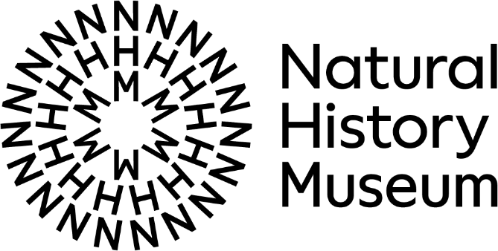
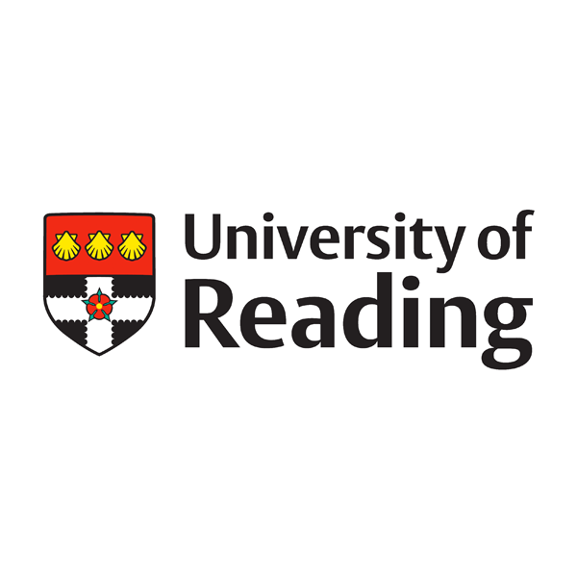
University of Reading and Natural History Museum Partnership Application for seed funding 2025-26
Funding is available to support the development of collaborative projects to be undertaken by researchers at the University of Reading and the Natural History Museum (including costs for proof of concept and proposal development, costs of meetings, travel and subsistence, research/clerical assistance etc.). Most requests should be for up to £2,000, but applications for up to £4,000 will be considered for more ambitious, interdisciplinary projects.
Examples of eligible projects include – but are not limited to – collaborative development of joint grant applications, network development, joint publications, and/or small-scale public engagement events.
Applications will be evaluated on a rolling basis, with outcomes communicated within two weeks from application in most instances.
Applications will be evaluated by the partnership’s Operational Delivery Group (ODG), with support from other senior members of staff at either institution if necessary. Projects will be assessed on their relevance to the Partnership’s six priority areas and the potential for beneficial impact in line with the two organisations’ strategic aims.
If awarded funding, it is expected that successful applicants will be prepared to provide a brief report on progress to the Partnership’s Operational Delivery Group if requested.

Please submit the application form to UoR-NHM-Partnership@nhm.ac.uk. Any queries can be directed to the same email address.

 | FOR INTERNAL USE ONLY:
Date Received: | Application No:

Section 1 – Applicants
Name(s) of NHM applicant(s):
Email(s):
Department/group:
Name(s) of UoR applicant(s):
Email(s):
School and Department:

Section 2 – Project - Funding
Title:
Start Date: | End Date:
Amount requested and breakdown of costs:
Funding from other sources (where appropriate, e.g. SIF, HoS, Research Centre):

Section 3 – Project – Description
Which of the Partnership’s Priority Areas does this project align with?
Select as many as applicable by ticking the relevant box(es)
[_] Research and Innovation | [_] People
[_] Skills | [_] Infrastructure
[_] Audiences and Collections
Describe your project, and how you will use the funding. You may wish to include a timeline, as well as links to relevant projects or literature. Please list any internal collaborators and partners as well as any beneficiaries. You should demonstrate how this project will enable or progress meaningful outcomes for your research and/or the strategic priorities of the organisation(s). (max 400 words)

